SEO Metadata
- Focus Keyword: best web design company in Kolkata
- Meta Title: Best Web Design Company in Kolkata (2026 Guide) | Brewing Ideaz
- Meta Description: Looking for the best web design company in Kolkata? Learn what to evaluate — UX, design quality, process, pricing & red flags — before you hire.
- URL Slug: /best-web-design-company-in-kolkata

Secondary Keywords
- web design company in Kolkata
- website design company in Kolkata
- web design services in Kolkata
- website development company in Kolkata
- professional web designers in Kolkata
- custom website design in Kolkata
- UI/UX design company in Kolkata
- responsive web design services
- website redesign services in Kolkata
- Brewing Ideaz Kolkata

Internal Linking Suggestions
- /services/ or /web-design/
- /contact-us/
- /portfolio/ or /case-studies/

Best Web Design Company in Kolkata: A Complete Guide to Choosing the Right Partner
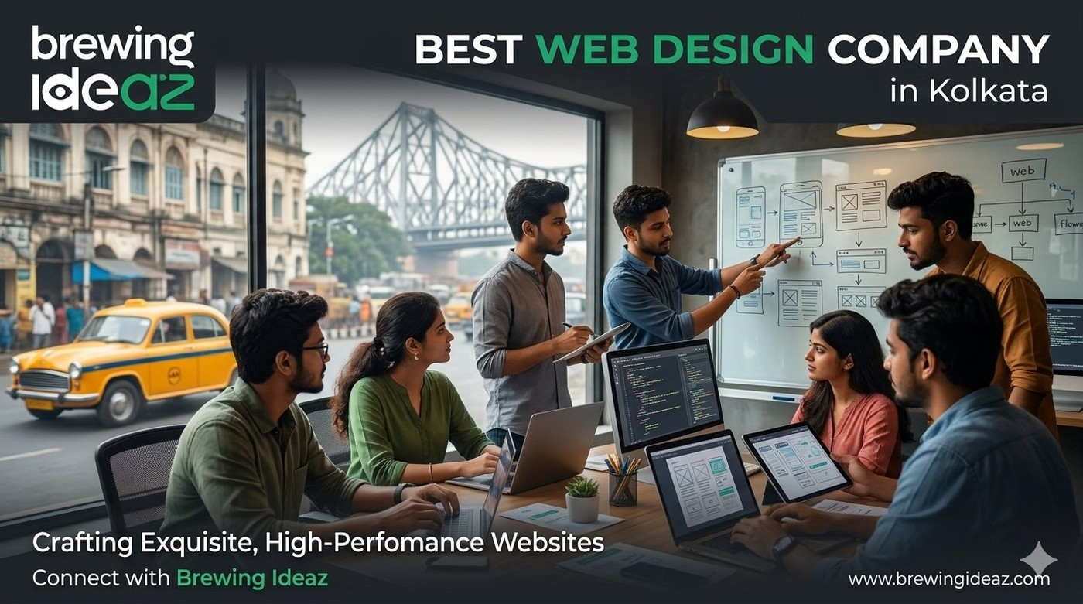
Your website is often the first detailed interaction a potential customer has with your brand. In Kolkata’s evolving business environment, many studios claim to be the “best web design company in Kolkata.” Quality, process and strategic thinking differ significantly. This guide gives you a practical way to evaluate options.

What “Best” Means in Web Design
A capable web design company creates more than a visually pleasing site. It should understand user needs and business goals, then deliver a website that is clear, fast, mobile-friendly, conversion-oriented and maintainable. The strongest partners combine research, UX, visual design and solid technical execution.
Fit is important. A studio that primarily builds brochure sites may not be ideal for a complex product or e-commerce experience.

Key Factors to Evaluate Before Hiring

Live portfolio quality
Review actual websites on mobile and desktop. Check speed, clarity and how design supports the goal.

Process and research
Strong teams invest time understanding users and objectives before designing.

Technical standards
Confirm responsive design, performance awareness, accessibility basics and clean development hand-off or full delivery.

Timeline and collaboration
Understand phases, revision rounds and communication methods.

Post-launch support
Clarify training, bug-fix period and ongoing maintenance options.

Ownership
Ensure you receive full ownership of design files and the final website.

Why a Kolkata-Based Web Design Company Can Help
Local teams understand the city’s market, share working hours, and often have experience with both traditional businesses and newer digital-first companies.

Questions to Ask Before You Hire
- Can you describe your discovery and design process?
- Do you have live examples similar to my project?
- How do design and development collaborate on your projects?
- What is a realistic timeline and how many revision rounds are included?
- What support is available after launch?

Red Flags to Watch For
Avoid companies that show only static designs with no live sites, promise unrealistic timelines, cannot explain their process, or price far below market without clear scope. Weak communication early on usually continues during the project.

Final Thoughts
The best web design company in Kolkata for your business is the one that understands your users and goals, designs with both aesthetics and usability in mind, and delivers a site you can own and grow.

Ready to Discuss Your Website Project?
Brewing Ideaz has a branch office in Kolkata (Bangur Avenue) and corporate office in Bengaluru.
Call or WhatsApp: (+91) 62915 47048 Email: info@brewingideaz.com

30 Frequently Asked Questions About Web Design Company in Kolkata
- What is a web design company? A web design company creates and designs websites based on a business’s goals, target audience, and requirements. Services may include visual design, UX, responsive layouts, and development.
- How do I choose the best web design company in Kolkata? Evaluate the company’s portfolio, design expertise, technical capabilities, project process, pricing, communication, and post-launch support.
- What services does a web design company provide? Website design, responsive design, UI/UX design, website redesign, landing page design, and website development.
- How much does a web design company in Kolkata charge? Pricing depends on complexity, features, design requirements, technology, and project scope.
- Why should I hire a professional web design company? To create a website aligned with your business goals that provides a consistent user experience across devices.
- What is the difference between web design and web development? Web design focuses on layout, visual appearance, and UX. Web development implements the design and builds the functionality.
- What is UI/UX design? UI design focuses on visual and interactive elements. UX design focuses on usability, navigation, and user needs.
- Why is responsive web design important? It allows a website to adapt to different screen sizes and devices.
- What is website redesign? Updating a website’s appearance, structure, UX, or functionality to better meet current needs.
- How long does it take to design a website? Depends on complexity, pages, features, content readiness, feedback, and testing.
- What should I prepare before hiring a web design company? Business goals, target audience, requirements, branding assets, content, budget, and timeline.
- What is a website wireframe? A simplified visual layout showing page structure, content placement, navigation, and key elements.
- What is a website prototype? An interactive or visual representation of a website demonstrating user flows before final development.
- What is the role of user experience in web design? How easily and effectively visitors can navigate and complete their intended tasks.
- Why is website loading speed important? A fast-loading website contributes to a better overall user experience.
- What is mobile-friendly web design? Design that ensures usability on smartphones, with readable text and accessible navigation.
- What is accessibility in web design? Designing so people with different abilities can use the site, including keyboard navigation and assistive technologies.
- What is a content management system (CMS)? Software that lets users create, manage, and update content without editing code directly.
- What is the difference between a custom website and a template-based website? A custom site is built to specific requirements; a template site uses a pre-designed layout with limited customisation.
- What is website maintenance? Ongoing updates, backups, security checks, bug fixes, and content updates.
- Will I own my website after the project is completed? Depends on the contract — clarify ownership of code, design files, content, domain, and third-party assets.
- What is included in a web design project? Discovery, wireframes, visual design, responsive layouts, development, testing, launch, and training, depending on scope.
- How do I evaluate a web design company’s portfolio? Review live websites, mobile usability, visual consistency, navigation, performance, accessibility, and relevance.
- Can a web design company help with SEO? Yes — SEO-friendly structures, responsive layouts, and clear navigation; ongoing SEO may require separate services.
- What is conversion-focused web design? Design aimed at helping visitors complete desired actions, such as submitting a form or making a purchase.
- What is the importance of website navigation? Clear navigation helps visitors find relevant information with less effort.
- What should I include in a web design contract? Scope, deliverables, timelines, fees, payment terms, revision limits, ownership, and post-launch support.
- What are common mistakes to avoid when hiring a web design company? Choosing solely on price, ignoring mobile usability, failing to define scope, overlooking ownership terms, neglecting post-launch support.
- Does a web design company guarantee website performance? A company may agree to specific technical requirements, but actual performance also depends on hosting, content, and integrations.
- How can I contact Brewing Ideaz for web design services in Kolkata? Call or WhatsApp +91 62915 47048 or email info@brewingideaz.com.

